**Assignment 15.1:**

1. Write a simple program to show inheritance in Scala.

Step1: Defined Class person

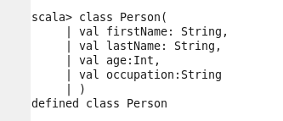

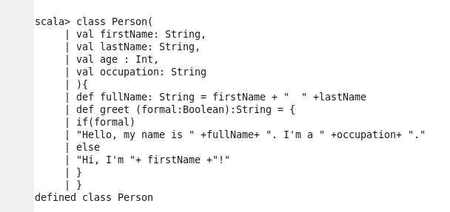

Step2: Defined Class Linguist

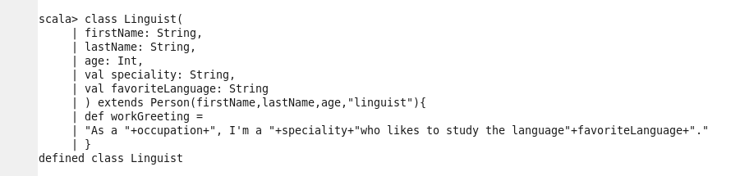

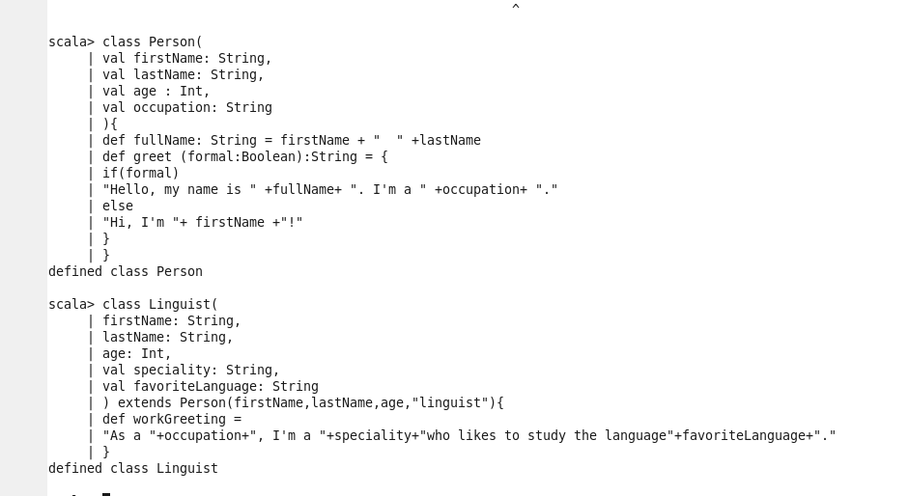

Step3: passing values to variables defined in above two class



Step4: printing data / text of a function defined in class ‘Linguist’



Step5: Printing ‘age’ of a person





Step6: Printing ‘favorite language of a person



